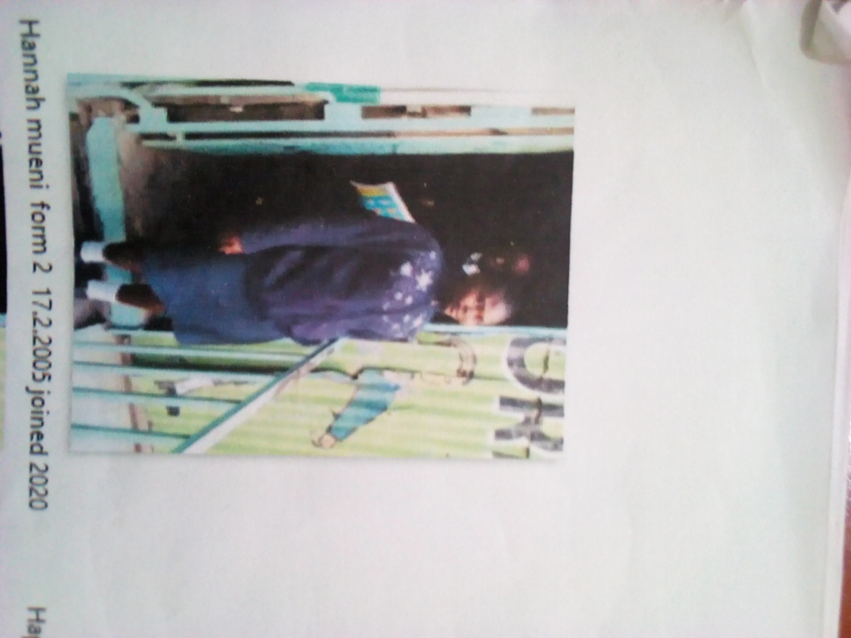

HANNAH MUENI FORM 2 BORN 2005 JOINED 2020
Hannah 16 years was enrolled in our school when he was 15 years old. Hannah is a needy girl, rescued from her parents when about to be married off. The parents were after getting money from a man older by 35 years and shut down her dreams. We also made sure her justice is served in the long run. She sought help in school and he became accepted in school after the Director was contacted.
Thanks to the Director Mr. Boniface Mangeti who allowed Hannah in school. I am now learning in glorious at least I have a place I call home praying that one day God will help our school have good classes, toilets and enough study materials. Thank you Michell and Brad for your support have really helped many in Mukuru

